**Performance Testing using Docker Compose**

1. Clone the git repository from <https://github.com/luketn/docker-k6-grafana-influxdb.git>

1. Navigate to the repo

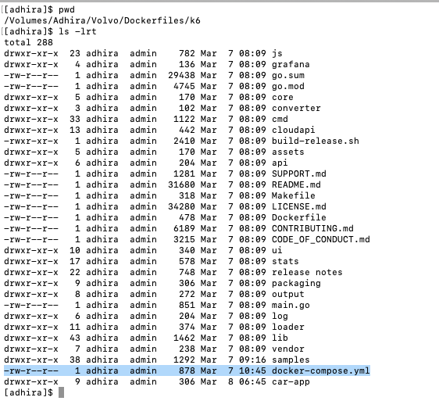

1. Edit docker-compose.yml file. For InfluxDB, image should be 1:8, NOT latest tag. This will avoid the error message in InfluxDB (couldn’t write your stats due to authorization issue)

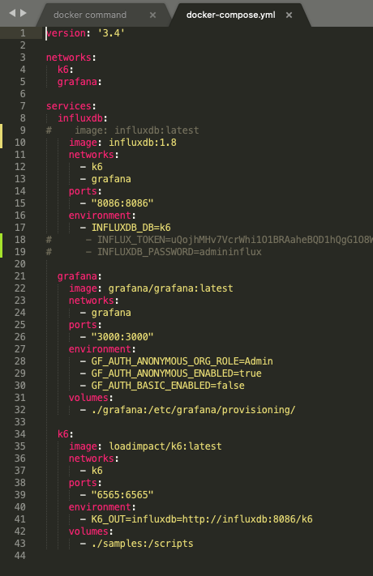

1. Execute the command “docker ps” to check the containers running in docker host

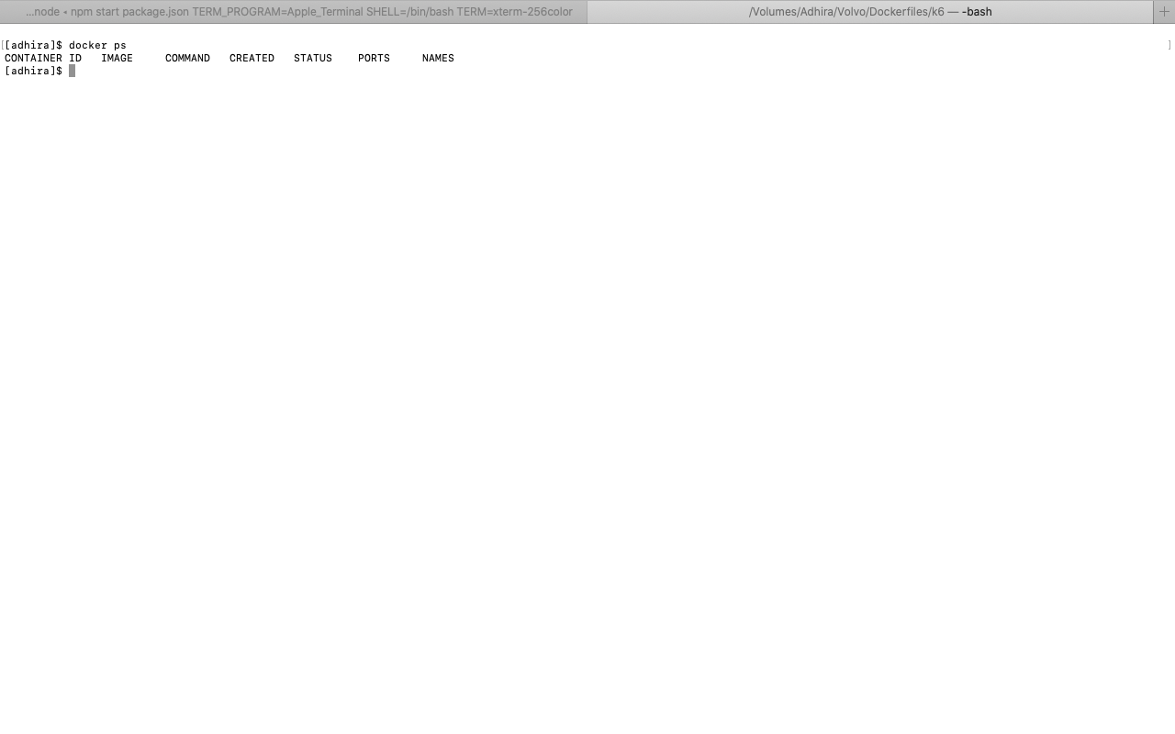

1. Spin up the docker images of influxdb and Grafana by running the command

“docker-compose up -d influxdb Grafana”

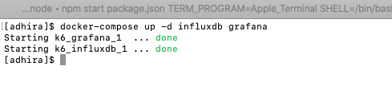

1. Execute the command “docker ps” to check the containers running in docker host. Now influxdb and Grafana are running



1. Open the browser and hit the URL <http://localhost:8086/>.
2. Create the datasource

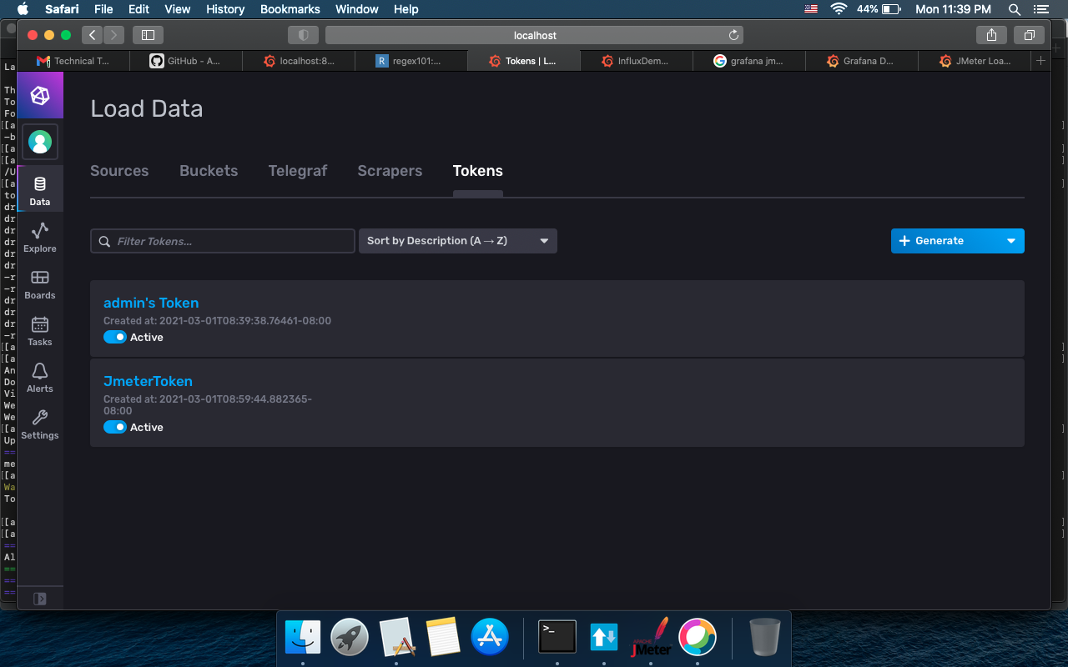

1. Open the browser and hit the URL <http://localhost:3000/>.

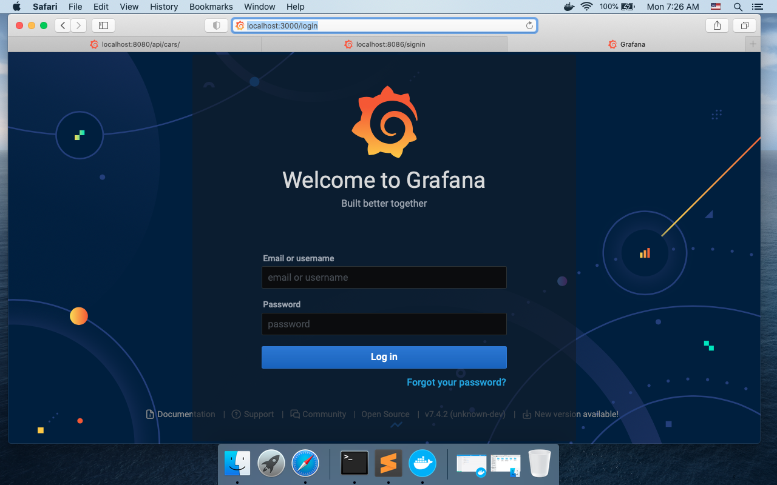

1. Login into Grafana (use admin/admin)

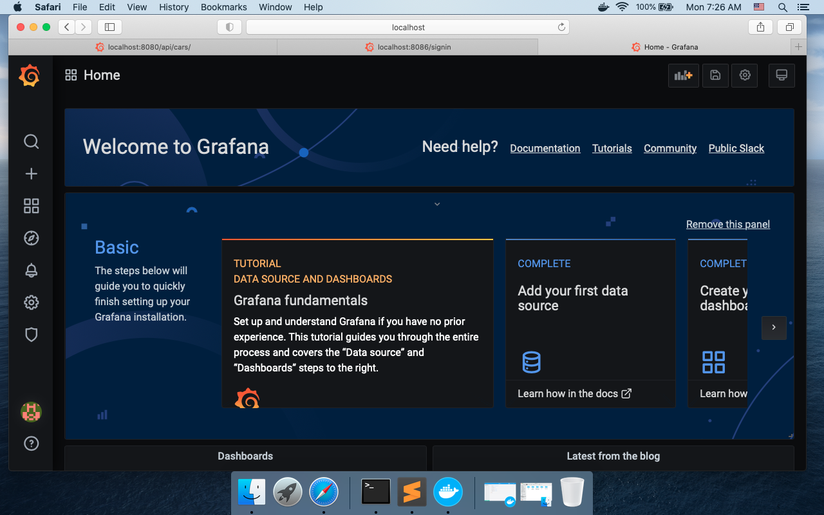

1. Validate the datasource created in influxdb

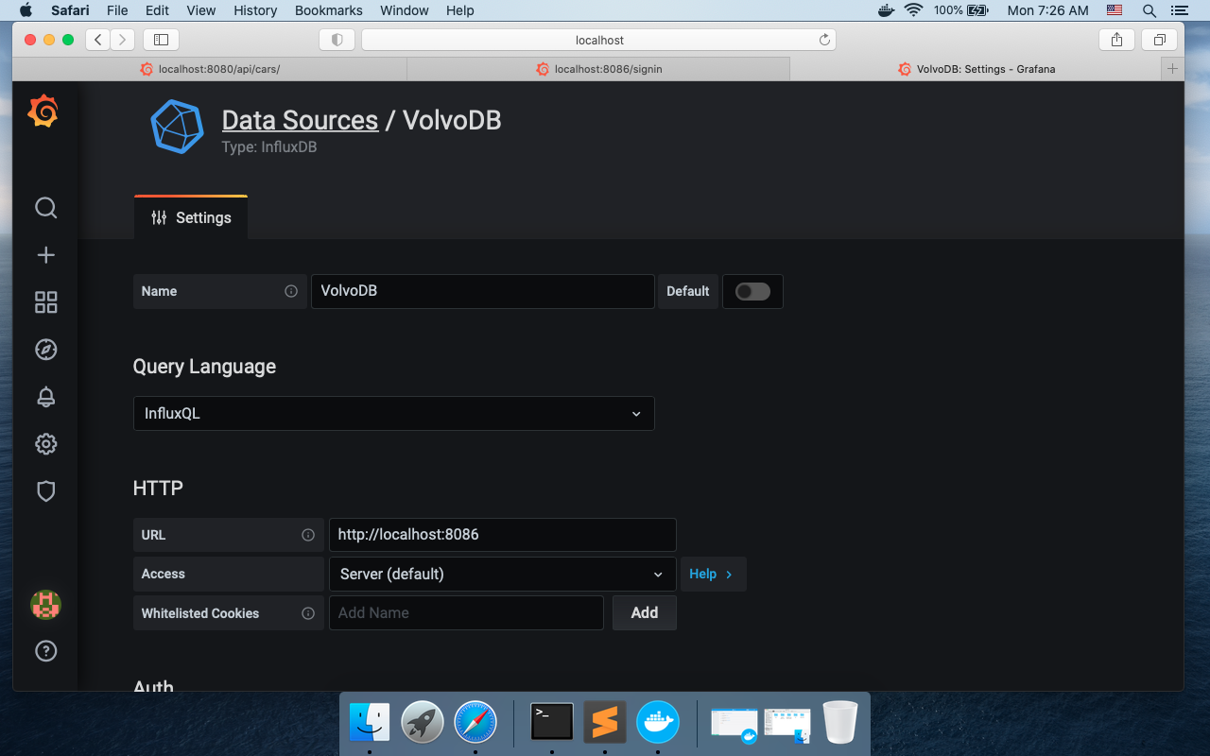

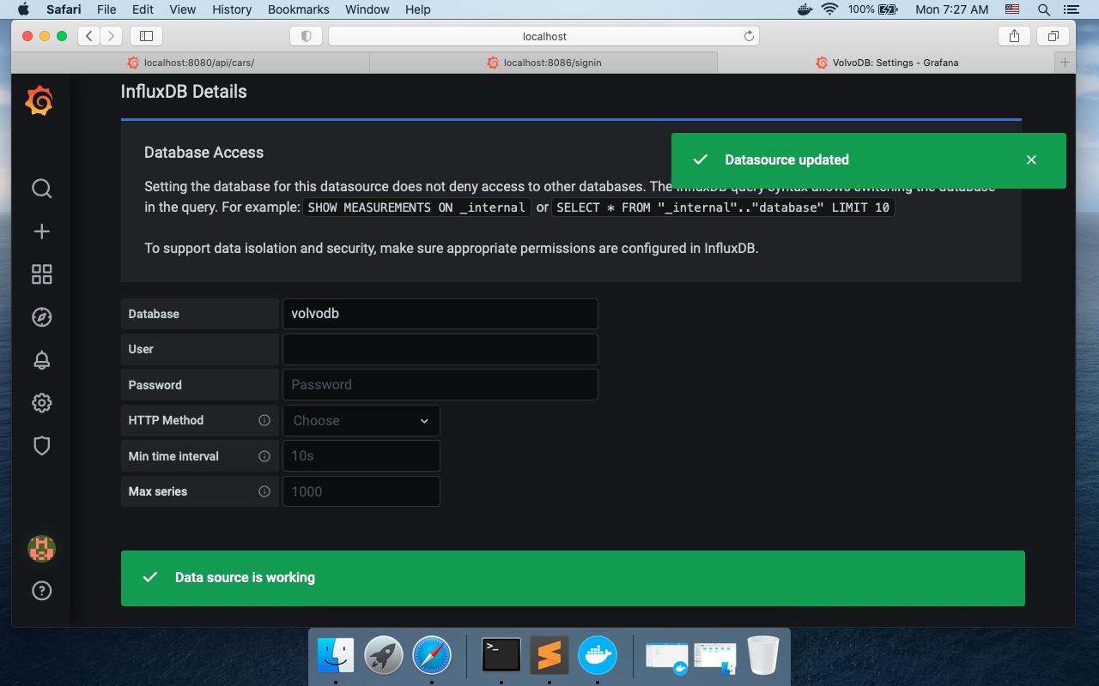

1. Execute the performance test by running the following command

“docker-compose run -v /<script path>:/scripts /k6 run /<script path>/<script name>.js

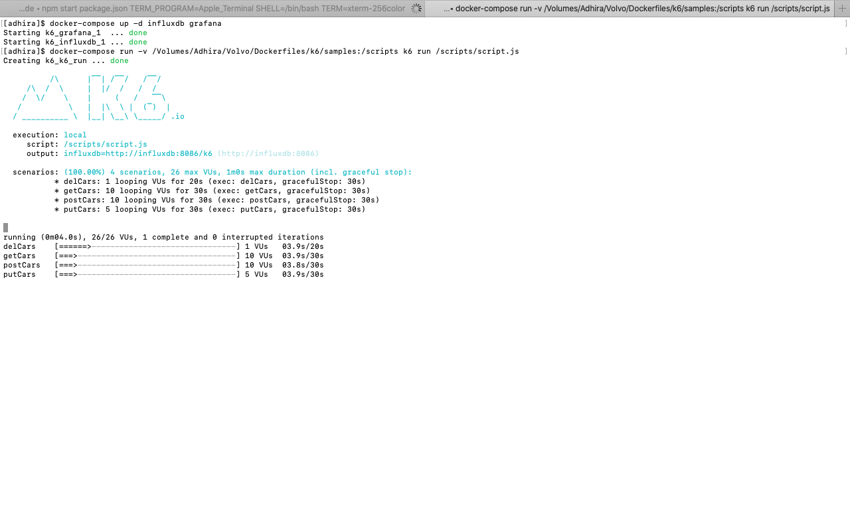

1. Open Grafana in browser and check the metrics

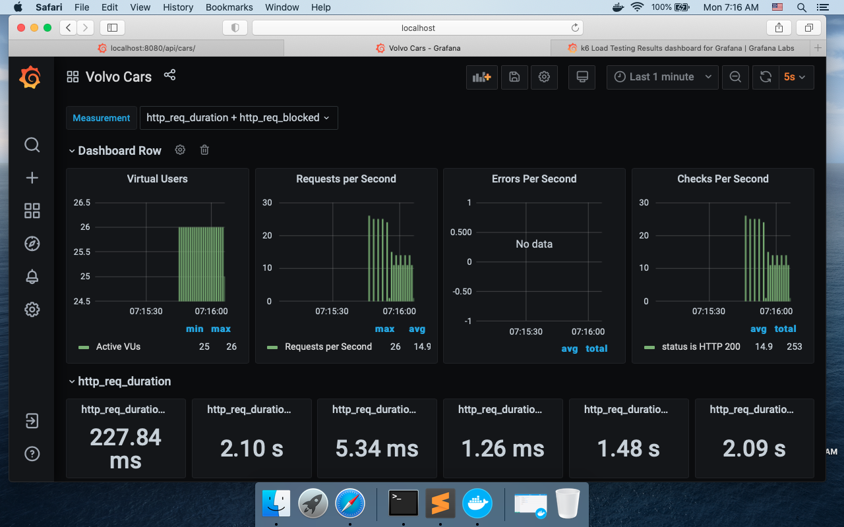

1. Screenshot of result

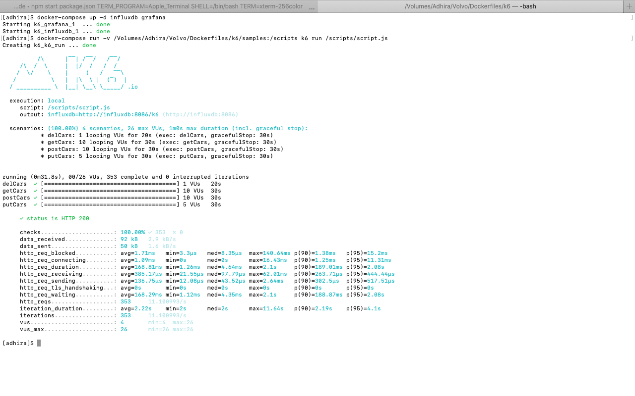

1. Kill docker containers after the test.